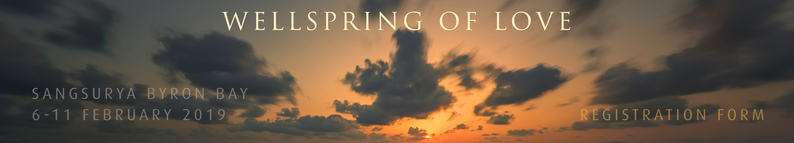

The information provided on this form will be viewed by the teacher, Caroline Pfohl, the meditation instructors and the retreat manager for this retreat. Any dietary requirements you list here will be shared with kitchen staff.
For more information on how information you provide to Dharma Ocean is used, maintained, protected and disclosed, please refer to the Dharma Ocean Privacy Policy available at https://www.dharmaocean.org/about/privacy-policy/.

RETREATANT DETAILS

PERSONAL DETAILS
NAME
ADDRESS
EMAIL ADDRESS
MOBILE NUMBER
GENDER
AGE

EMERGENCY CONTACT DETAILS
NAME
RELATIONSHIP
PHONE NUMBERS

SPECIAL REQUIREMENTS

Vegetarian meals will be provided on retreat. Please advise if you require any of the following alternatives:

[ ] Vegan
[ ] Gluten Free
[ ] Dairy Free
[ ] Sugar Free

Do you have any food allergies that we should be aware of?

Occupation / life situation

MEDITATION PRACTICE AND INSPIRATION

Please describe your practice history and inspiration for attending this program.

Please outline what Dharma Ocean programs (online or residential) you have taken part in.

Do you require a chair for sitting meditation?

Do you have hearing loss (even mild) that sometimes requires assistance? If so please describe.

Is there anything else we need to know about your registration?

CARE AND SUPPORT

Somatic meditation is generally safe, and practices and positions can be adapted for individual situations. However, as with any form of meditation, some participants may find that challenging emotional, mental, or even physical material arises. This retreat offers the space and guidance for working with what arises, so that our experience itself becomes a teacher and a vehicle for healing. If you have any concerns about your ability to participate in intensive meditation at this time please email wellspringoflove@dharmaocean.org

Do you have any current or past medical or physical conditions that are important for us to know about?

Have you ever received inpatient care for psychiatric, mental health, or addiction issues?
if yes, please describe:

Do you have concerns about engaging in intensive meditation practice at this time? Do others close to you (such as medical professionals, mental health professionals, or family members) have concerns?

Do you have or have you had any alcohol or drug dependency? If yes, please describe and state whether past or current.

Do you have any serious allergies (e.g. bee stings, penicillin, nut allergies, etc.)? If yes, please specify and explain how we should best respond in the event of a medical emergency.

Do you have a healthcare background, and are you willing to assist in the case of an emergency?

PLEASE EMAIL YOUR COMPLETED FORM TO:
wellspringoflove@dharmaocean.org

If there is any change in your circumstances after submitting this registration form,
please inform the retreat manager by emailing:
wellspringoflove@dharmaocean.org

